Dalton Murray

Systems Analysis and Design

INT 6123 – Systems Analysis and Design

Dr. Andrew Makar

September 24, 2023

**IA #4Spring Breaks R Us**

**Question 1 – For the Social Networking subsystem as described here, list the domain classes and their attributes that should be included in the Social Networking subsystem. Be creative and add those you think should be included to make the system useful and appealing.**

A domain class is a class which describes things in the problem domain while a class is a category or a sort of classification which is used to describe a collection of objects (Satzinger et al., 2016. p. 103). For example, a domain class could be a student and its attributes could be the resort they’re staying at, their age, the group size, and many other things.

Specifically, for SBRU I have figured out these classes and their attributes:

* **Traveler/Student**
  + firstName
  + lastName
  + address
  + phoneNumber
  + emailAddress
  + reservationSize
  + checkInDate
  + checkOutDate
  + invitees
* Interests/Hobbies
  + typeOf
  + descriptionInterestHobby
  + specificInterestHobby
* Post
  + timeOfPost
  + pictureOfLocation
  + rating
  + postOriginalComment
* Resort/Party location
  + resortName
  + resortAddress
  + resortPhoneNumber
  + resortEmailAddress
  + roomNumber
  + roomSize
  + pricing
  + packages
* NetworkedConnection
  + firstName
  + lastName
  + phoneNumber
  + emailAddress
* Invitee
  + firstName
  + lastName
  + phoneNumber
  + emailAddress

**Question 2 – Based on the domain classes you identified, draw a domain model class diagram showing domain classes with attributes and associations with multiplicity.**

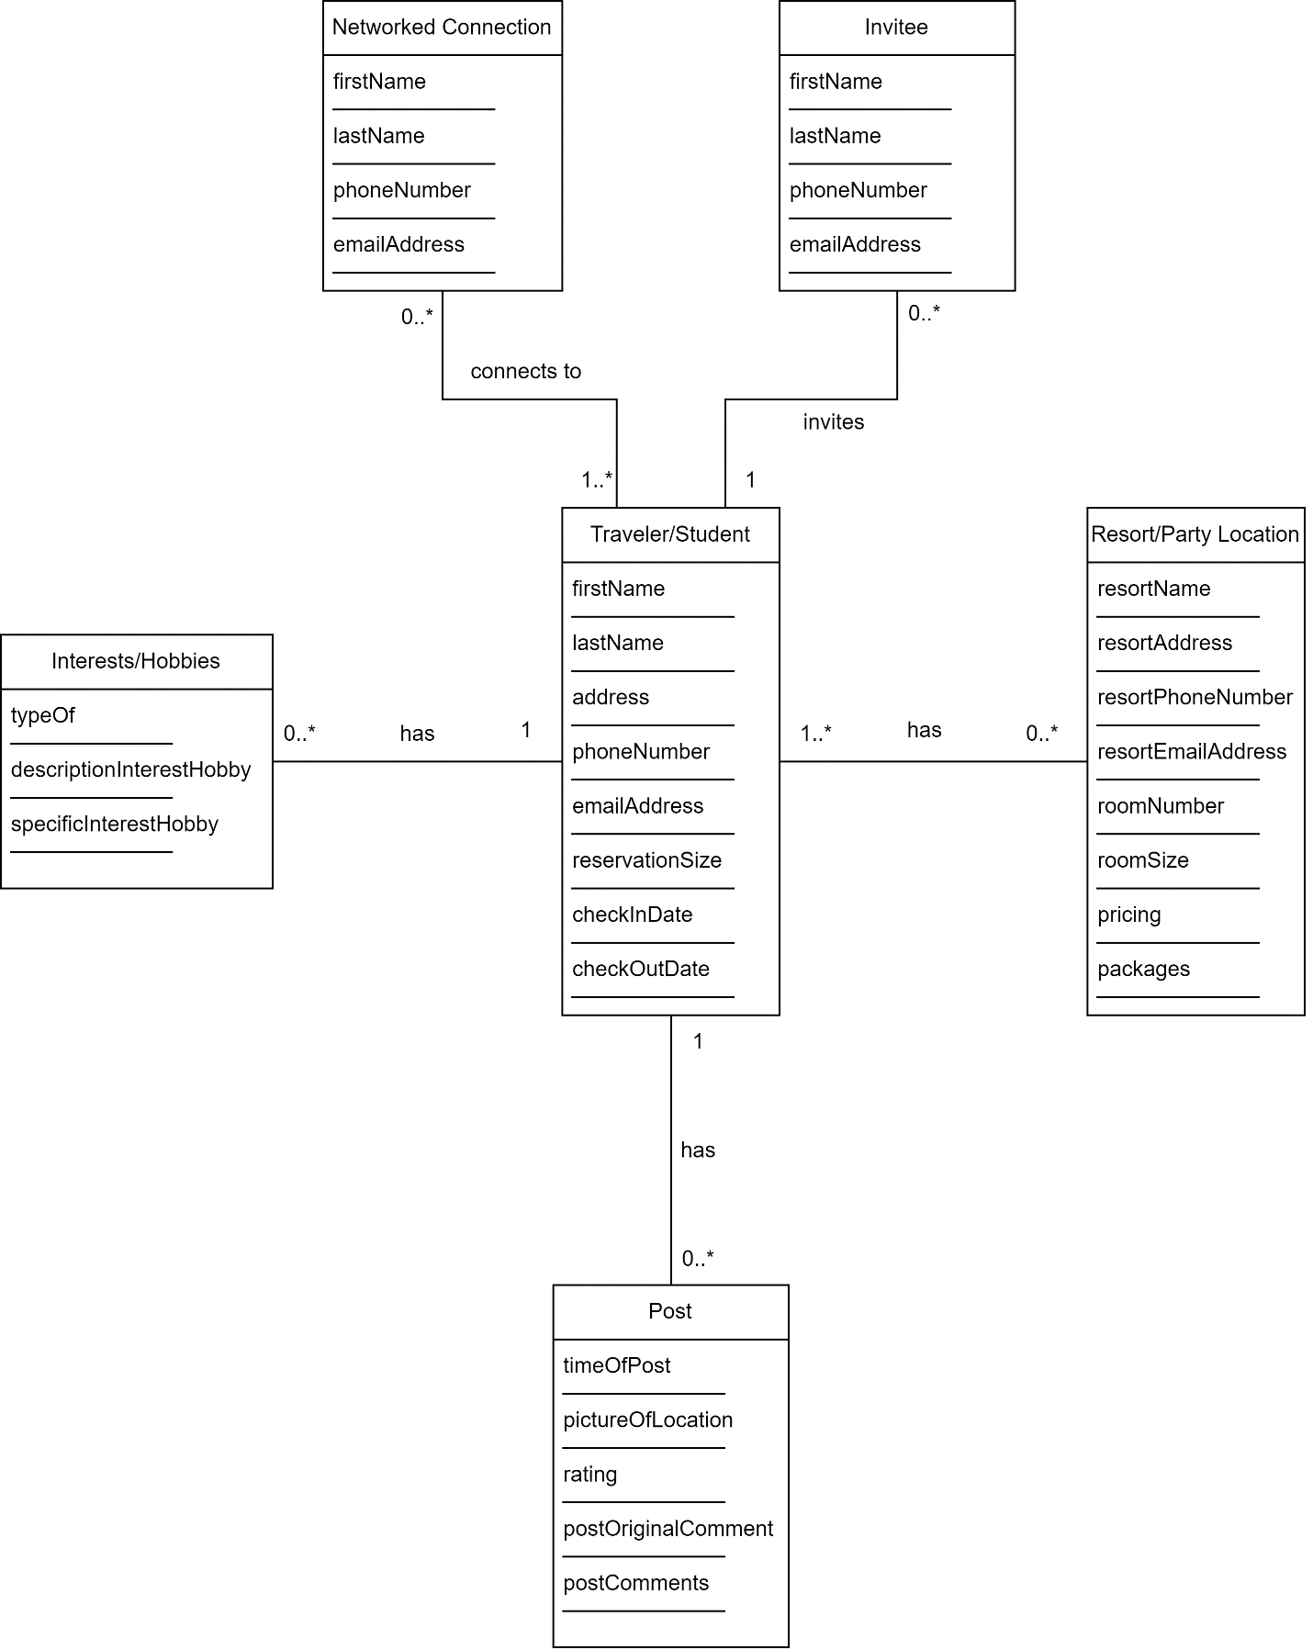

**References**

Satzinger, J. W., Jackson, R. B., & Burd, S. D. (2016). Systems analysis and design in a Changing World (7e ed.). Cengage Learning.

I have neither given nor received unauthorized aid in completing this work, nor have I presented someone else's work as my own.

*Dalton Murray*